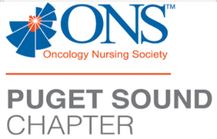
PSONS’s Zoom Education

Tuesday, May 9th, 2023 at 6:00pm

6:00pm, the Zoom application will go live with PSONS announcements, 6:15pm product update, 6:30pm the show starts

“Artistry To Take You Beyond Surgery”
Speakers:
Eric Eye, Restorative Tattoo Arts
Hannah McCabe, ARNP, Franciscan Plastic Surgery Associates, Tacoma, WA
Kerry Morrison, RN, OCN, St. Joseph Medical Center, Tacoma, WA

Zoom virtual meeting
To your computer, smartphone, or tablet with the Zoom App

6:00, the Zoom application will go live with PSONS announcements, 6:15pm product update, 6:30pm the show starts

RSVP by May 9th, 3pm

You must pre-register via this link to get the Zoom information. You will automatically receive the info you need to connect to the program.
Register in advance for this meeting:

https://us02web.zoom.us/meeting/register/tZIkc-GvqT4oHtSEsO8Xue1qlgpDQ1DoOLcN

Any questions?
Please email us: psonssouthsoundeduc@gmail.com

This activity does not have commercial sponsor support

Please notify the event coordinator (including contact information) at least 24 hours prior to the event in the case of a cancellation. Education Activity Sponsor/Provider (Seattle Cancer Care Alliance & PSONS)

Provider approved by the California Board of Registered Nursing, Provider #16496, for 1.6 Contact Hours (pending)

