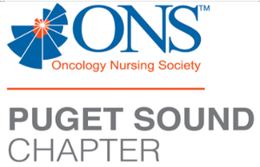
PSONS’s Zoom Education Event

Thursday May 23rd at 6:15pm PST/5:15pm Alaska Time

6:00pm, the Zoom application will go live, 6:15pm PSONS chapter updates & announcements, 6:30pm the “show” starts

“What I Learned and Experienced When I attended the 2024 ONS Congress”

Speakers:
Lyndsey Conway, Amy Boswell, Keitrah Oakley, Anh Thu Le, Soyoung Park and Shermila Waljee

RSVP by May 20th, 3pm Any questions? Please email psonseducation@gmail.com

You must PRE-REGISTER to attend this event

https://us02web.zoom.us/meeting/register/tZYrdOyurjgsHNAdusvscJ_qRuaHIUTPUXvR

This activity does not have commercial sponsor support

Please notify the event coordinator (including contact information) at least 24 hours prior to the event in the case of a cancellation. Education Activity Sponsor/Provider (FHCC & PSONS)

Provider approved by the California Board of Registered Nursing, Provider #16496, for 2.2 Contact Hours (pending)

