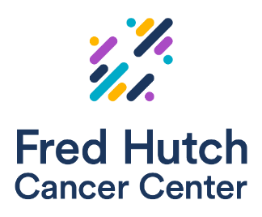

PSONS April Hybrid Education Event

Wednesday, April 30, 2025
6:00 pm PST / 5:00 pm Alaska Time
at Palisade, 2601 W Marina Pl, Seattle, WA 98199

Providing Palliative Care to People with Cancer:
An Inquiry

Speaker:

AGENDA

5:30 pm In-person attendee check-in begins
6:00 pm Zoom goes live
6:15 pm PSONS chapter updates & announcements
6:30 pm CE presentation

Mark Beiter, DO
Virginia Mason - Palliative Care

RSVP by April 23, 2025 @ 3 pm (pre-registration required)
Any questions? Please email psonseducation@gmail.com

Paid in-person registration for non- PSONS members is $10
(credit card payments only)

Virtual registration is free to members and non-members

Objectives: Participants of this program will:
- Define palliative care
- Explain the evidence for palliative care
- Identify appropriate candidates for palliative care
- Explain how palliative care partners with departments to improve care for patients living with cancer
- Describe one way to improve access to Palliative Care for patients living with cancer

Education Activity Sponsor/Provider (FHCC & PSONS)

Provider approved by the California Board of Registered Nursing, Provider #16496, for _1.2 hours_(pending)

